|  |  |  |  |  |  |
| --- | --- | --- | --- | --- | --- |
| Date | 6-Dec-22 | | | Tester Name | Richard Belanger |
| Environment | Penfax - Test | | | Login used | TEST2 |
| Operating System | Windows | Version: | Update: | | |
| Software Used | Edge | Version: | Update: | | |
| Not Applicable | Version: | Update: | | |
| Release version | 22.4.1 | | | | |
| Title | M12.04 General seasonal member with regular service types | | | | |
| Test Type | Regression | | | | |
| Test Scenario | Member will have Death calculation processed | | | | |
|  |  | | | | |
| Expected Results | The member will be terminated and beneficiary paid | | | | |
| Pass/Fail | Select | | | JIRA# | N/A |

Describe your steps with screenshots:

Member terminated due to death

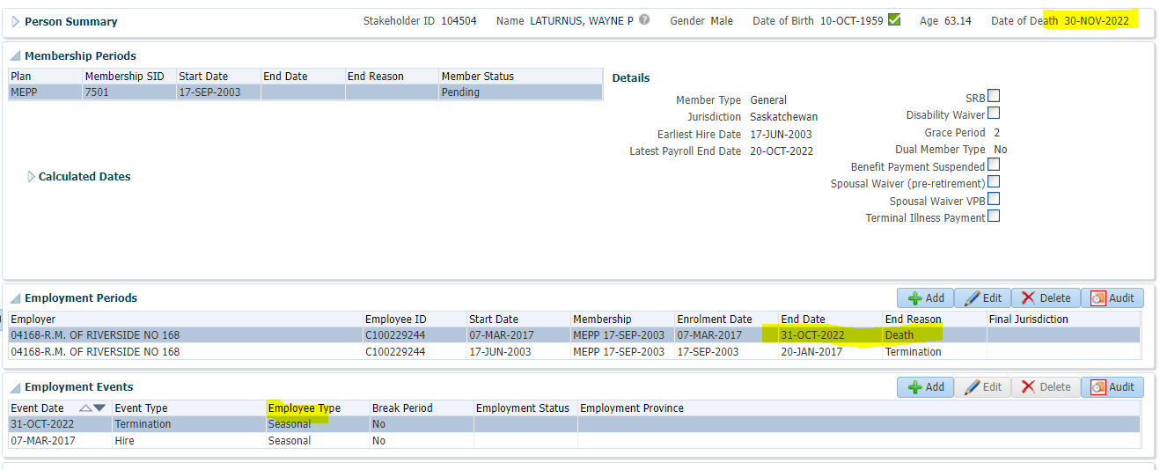

To Benefit Calculation>Calculate

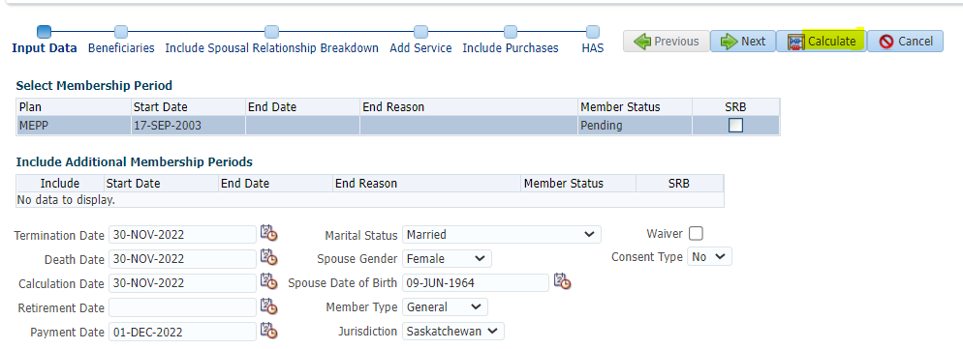

Processed

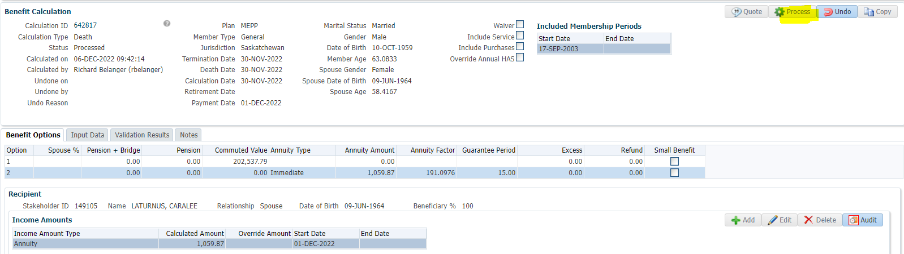

To Benefit Selection>Next

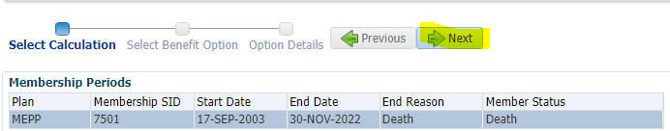

Choose Option add payment date>Next

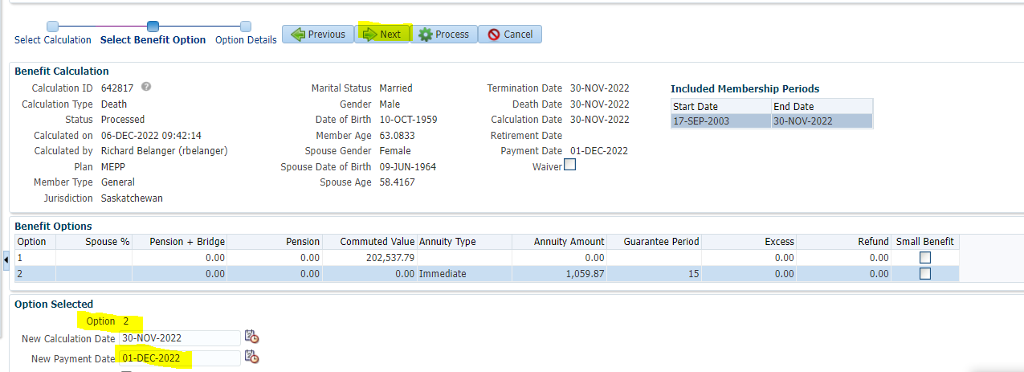

Add Payment/Tax Instructions>Process

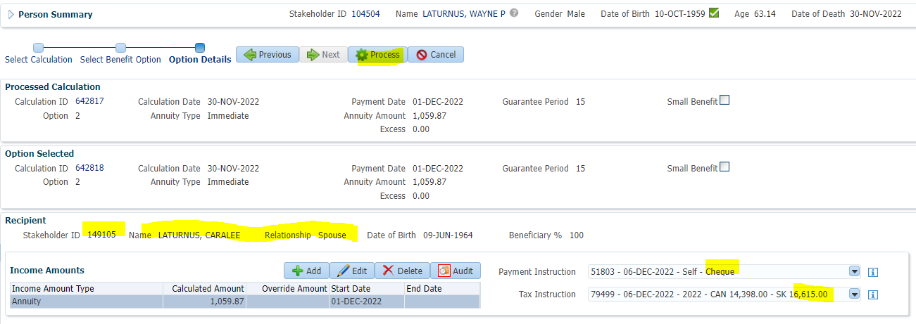

Processed>To Beneficiary>Benefit Recipient>Income Benefit

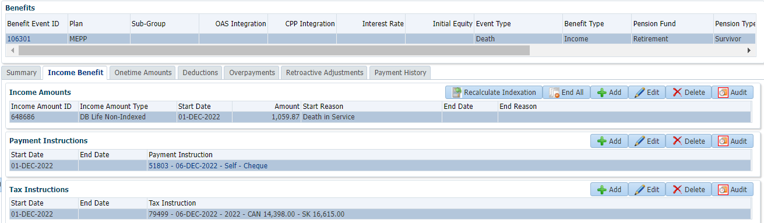

To Summary>Authorize

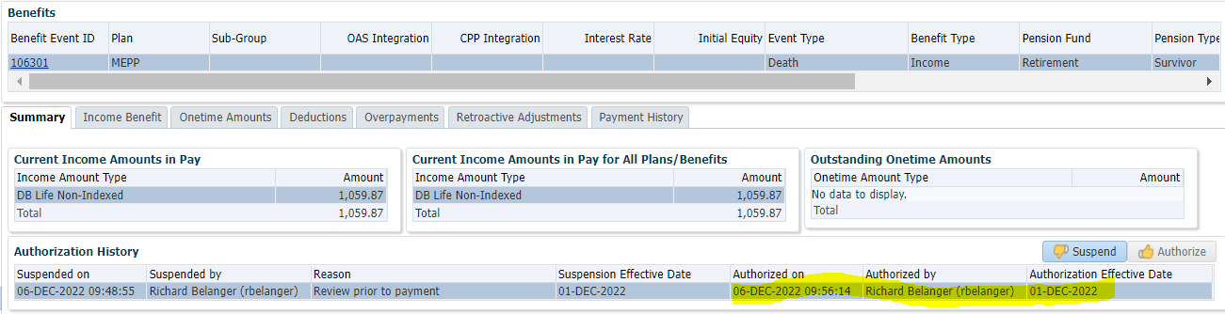

Payment Batch to run to see pension payment made to Beneficiary